AWS LAB - 6: Scale and Load Balance Your Architecture

Vishakha Maruti Sonmore (CSULB ID: 032188141)

College of Business, California State University, Long Beach

Course Number: I S 602 Sec08 12348 Management Information Systems

Instructor: Dr. Santos Galvez

Due date: 03-Dec-2023

**AWS LAB - 6: Scale and Load Balance Your Architecture**

This lab demonstrates how to load balance and automatically scale your infrastructure using the Elastic Load Balancing (ELB) and Auto Scaling services.

**Task 1: Create an AMI for Auto Scaling**

In this task, you will create an AMI from the existing Web Server 1. This will save the contents of the boot disk so that new instances can be launched with identical content.

* In the AWS Management Console, in the search box next to Services , search for and select EC2.

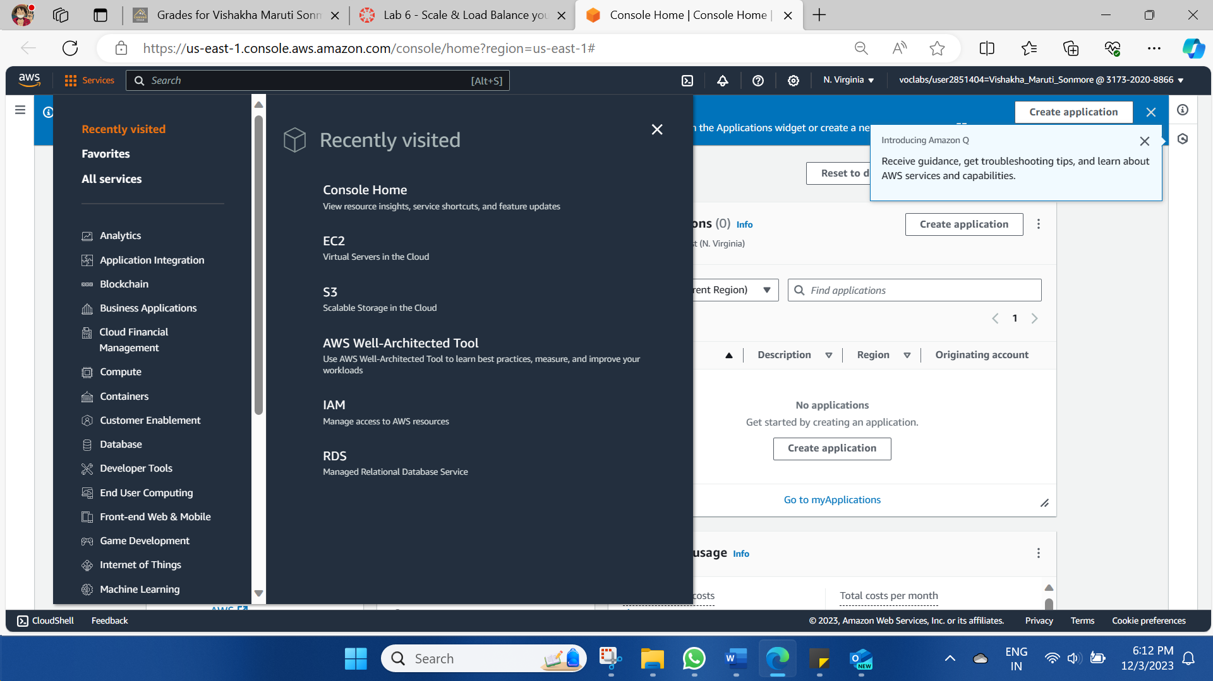

* In the left navigation pane, choose Instances.
* First, you will confirm that the instance is running.

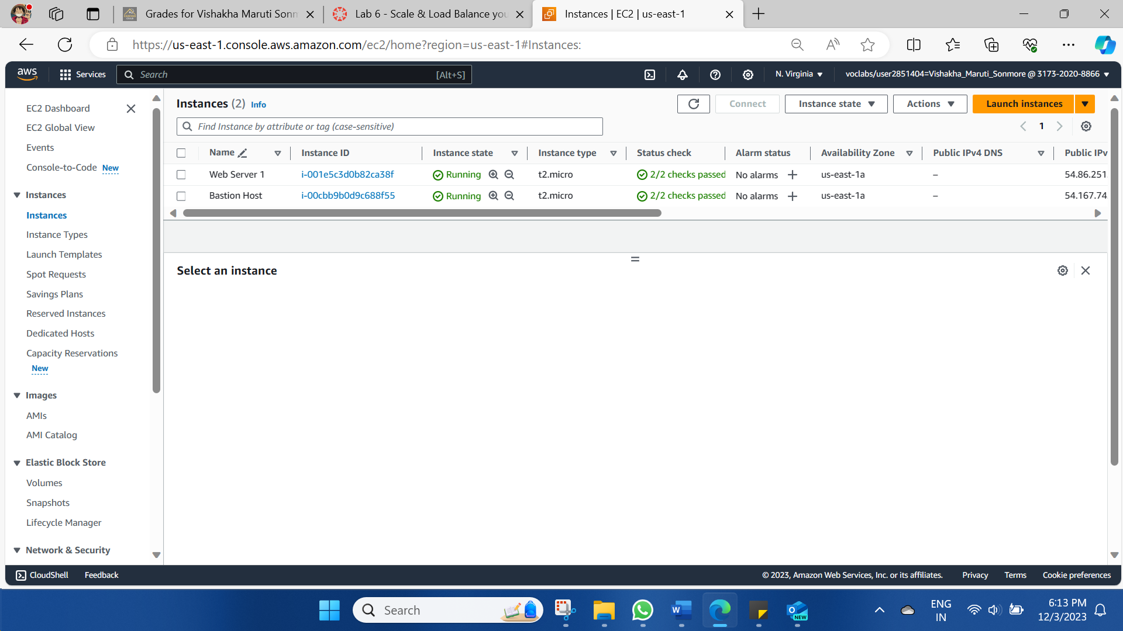

1. Select **Web Server 1**.
2. In the **Action**menu, choose **Image and templates** > **Create image**, then configure:
   * **Image name:** WebServerAMI
   * **Image description:** Lab AMI for Web Server
3. Choose **Create image**

A confirmation banner displays the **AMI ID** for your new AMI.

You will use this AMI when launching the Auto Scaling group later in the lab.

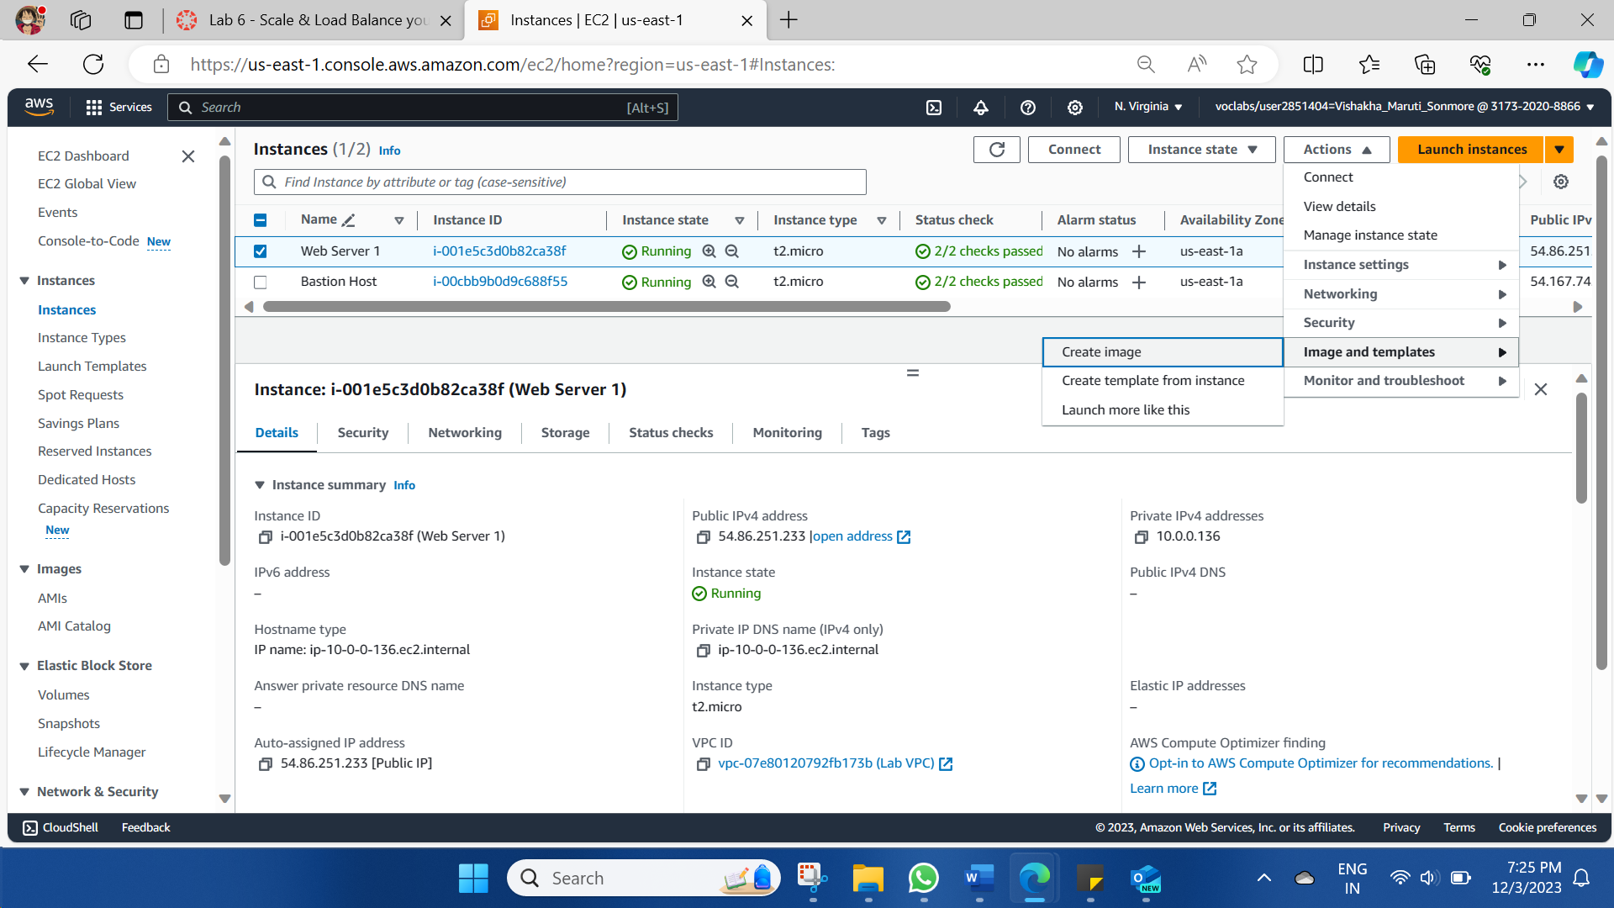

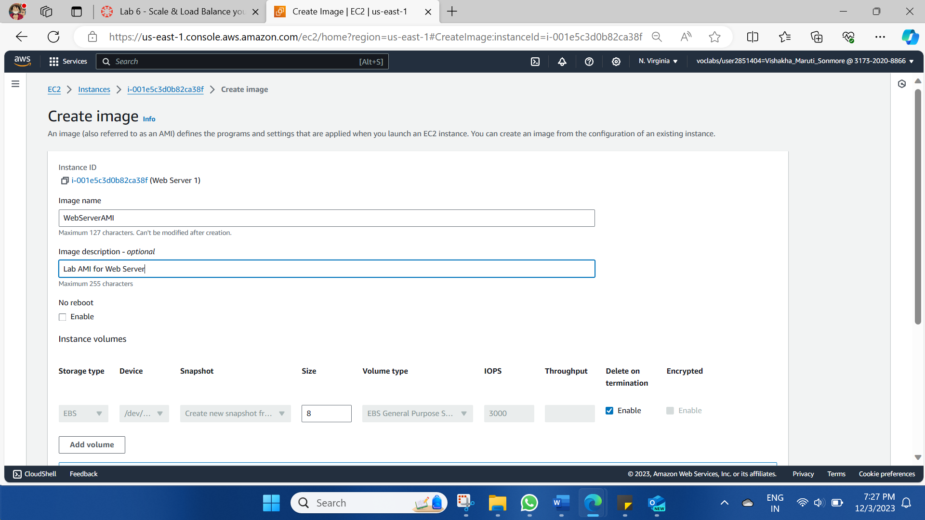

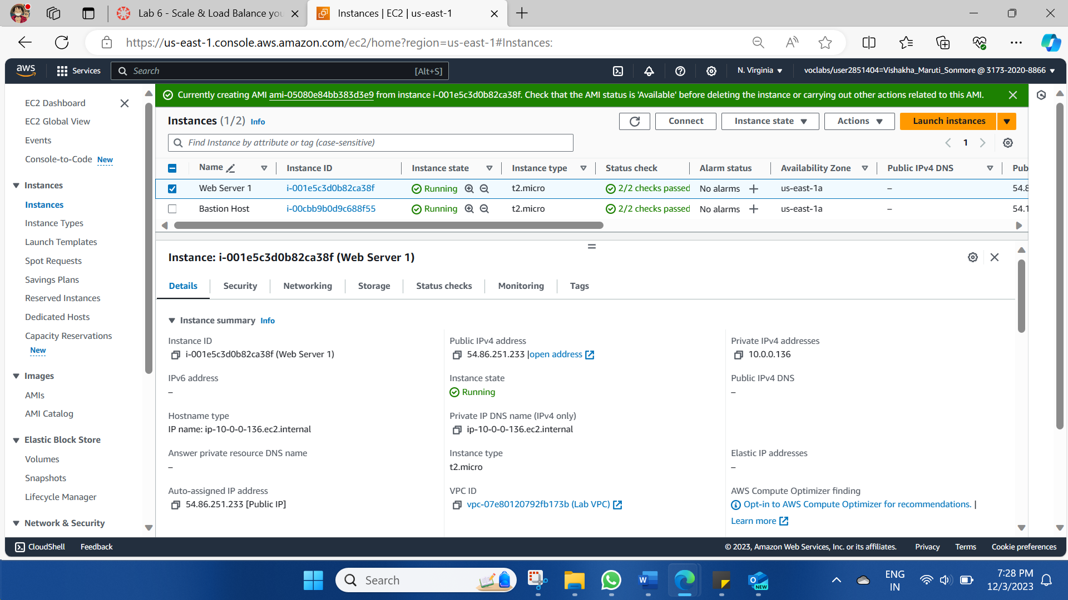

**Task 2: Create a Load Balancer**

In this task, we will create a load balancer that can balance traffic across multiple EC2 instances and Availability Zones.

* In the left navigation pane, choose Target Groups.

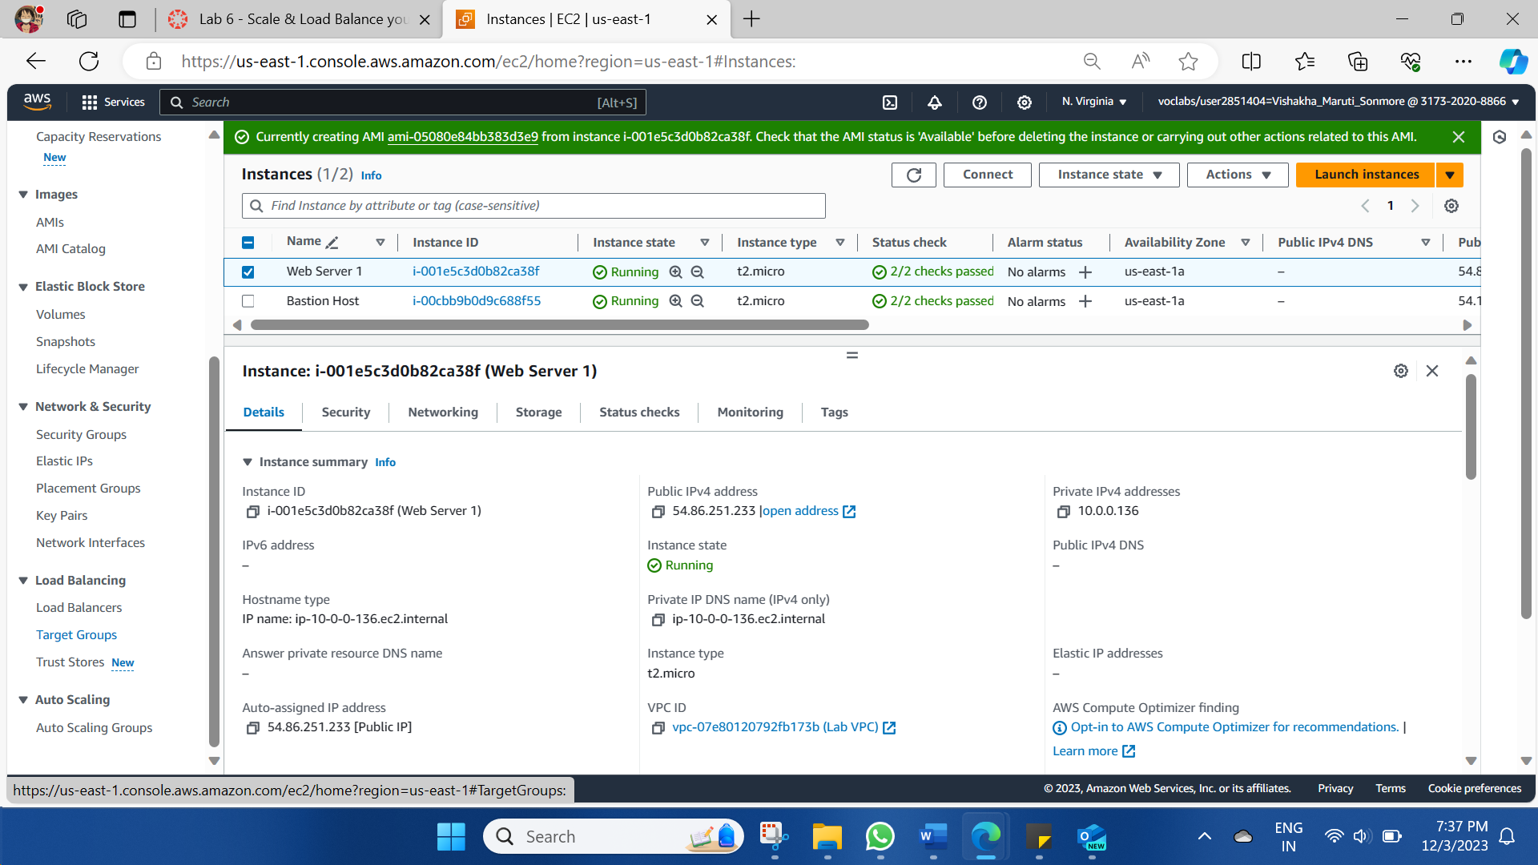

* Choose Create target group >> Choose a target type: Instances >> Target group name, enter: LabGroup >>Select Lab VPC from the VPC drop-down menu.

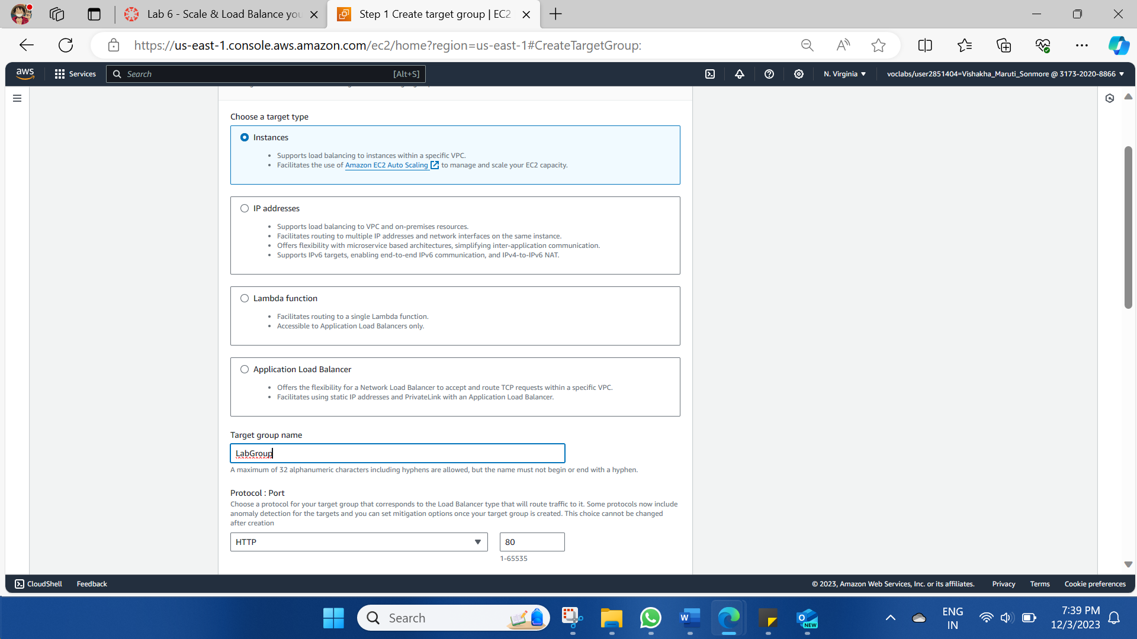

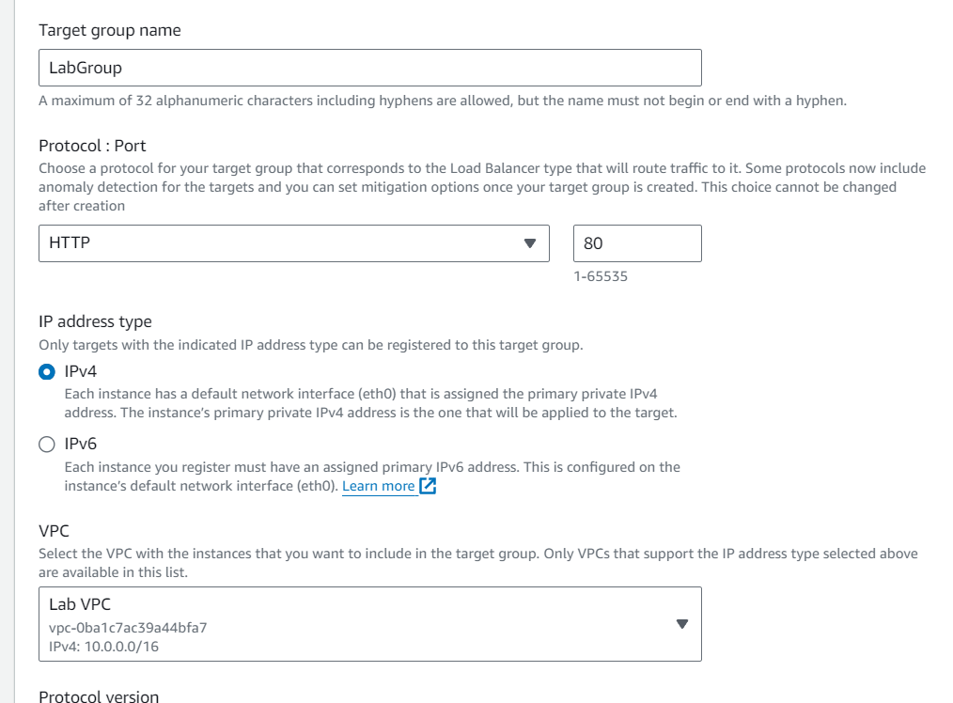

Target Group created.

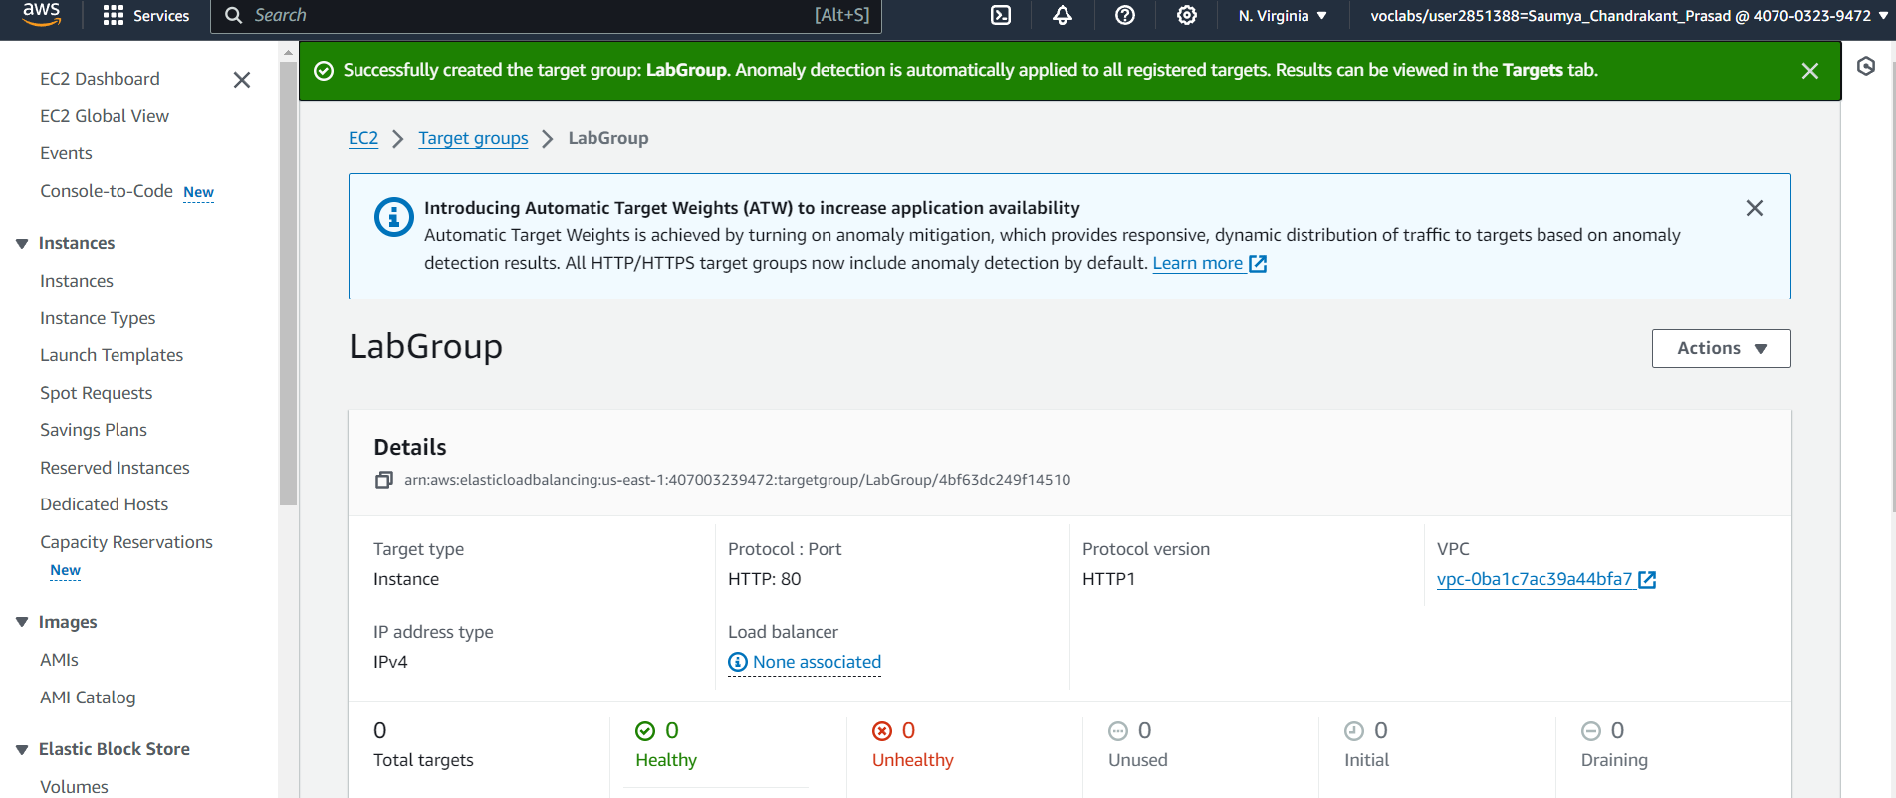

Creating Load Balancer

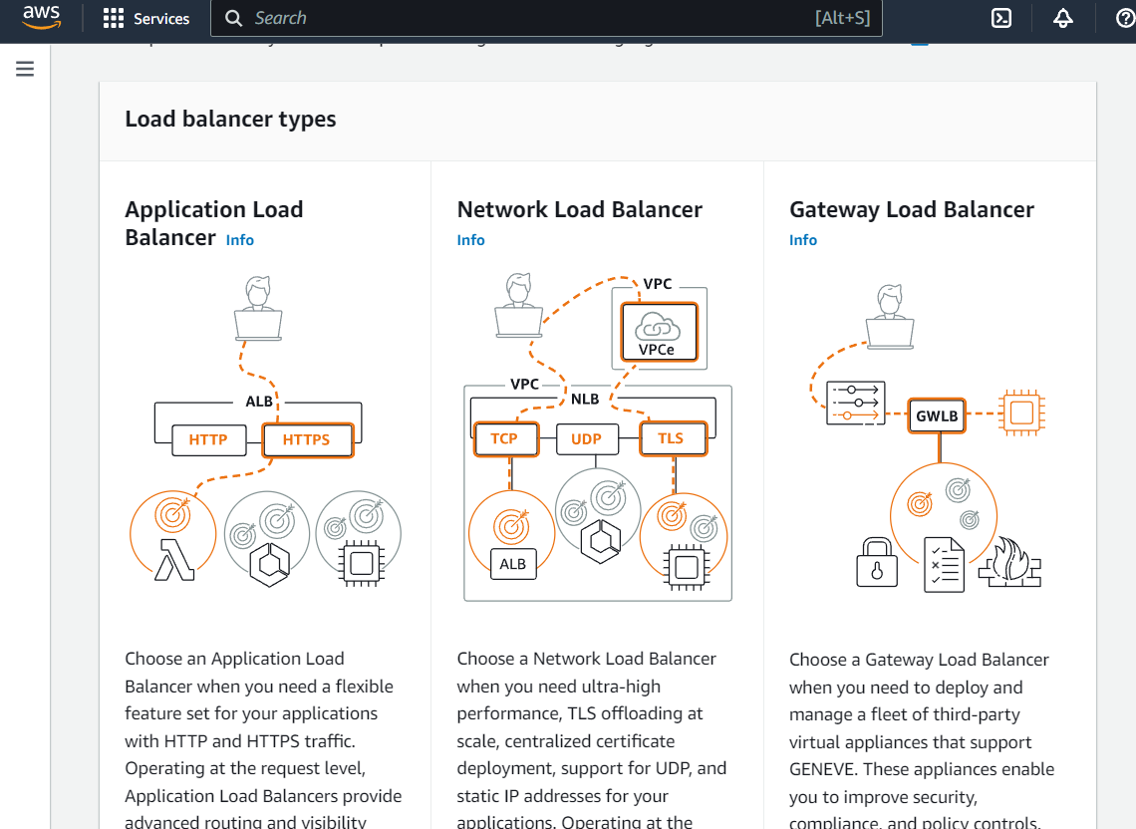

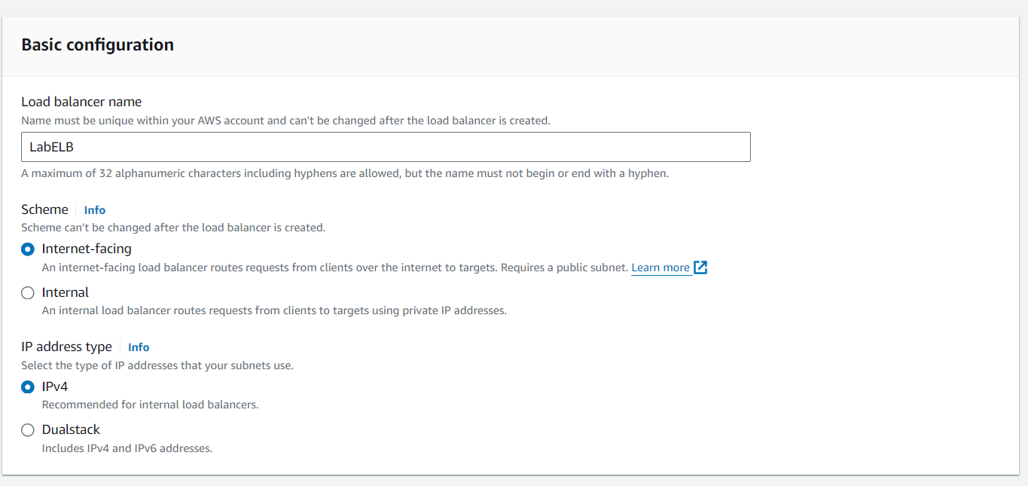

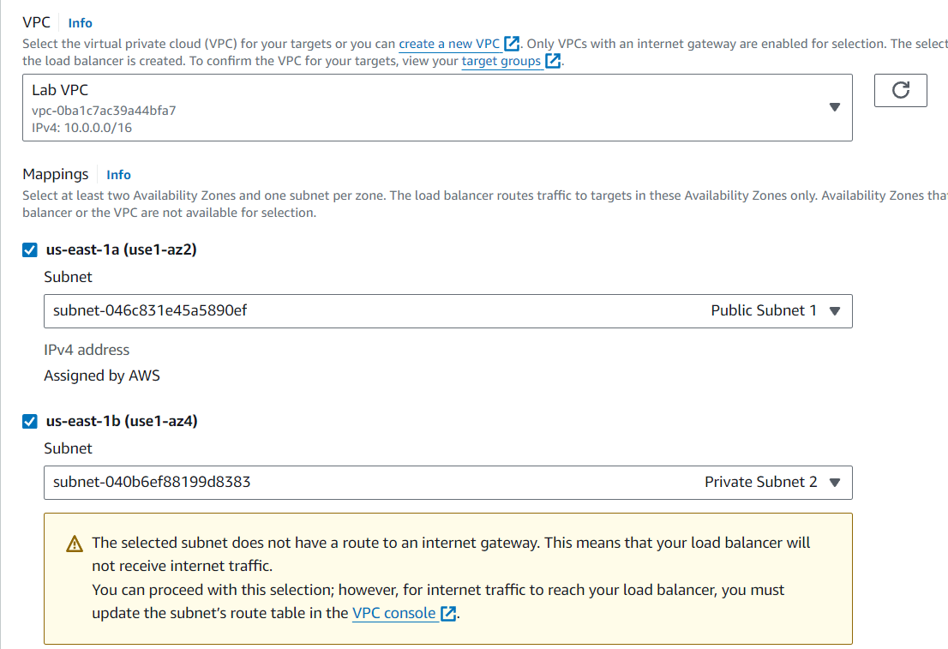

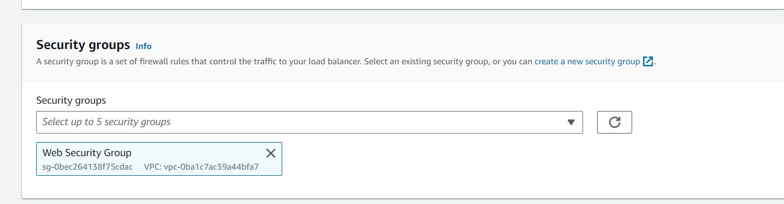

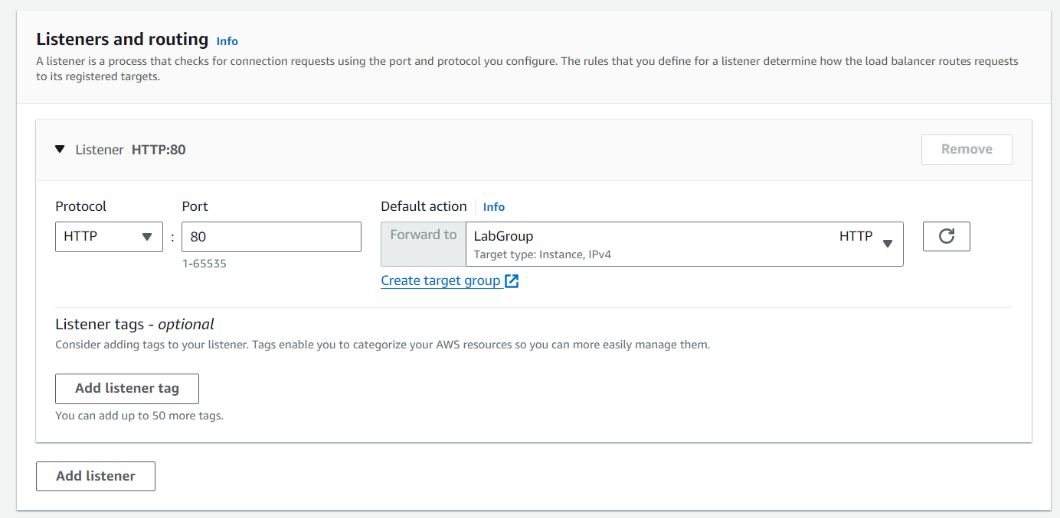Load Balancer in creation

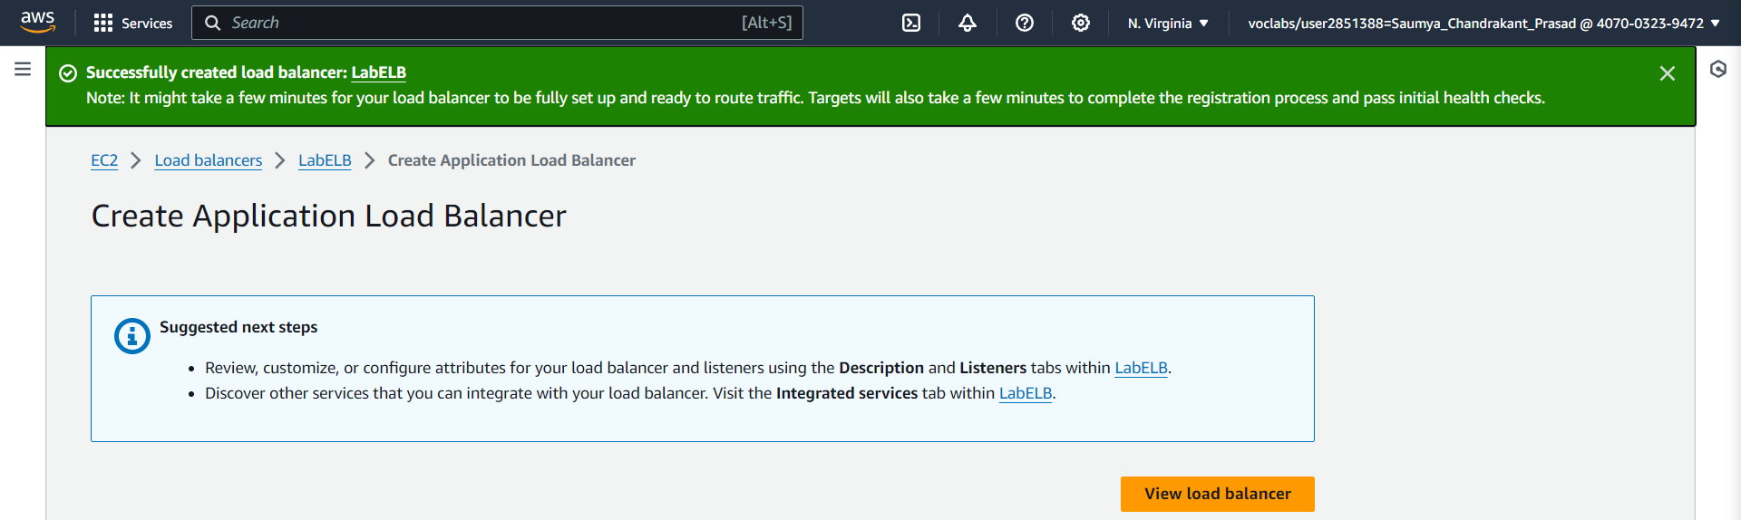

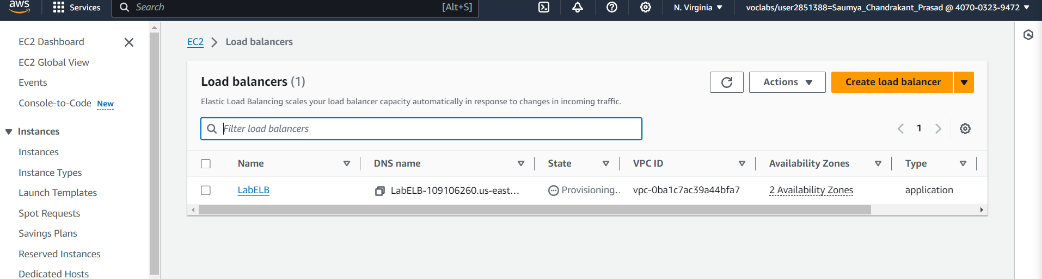

**Task 3 - Create a Launch Template and an Auto Scaling Group**

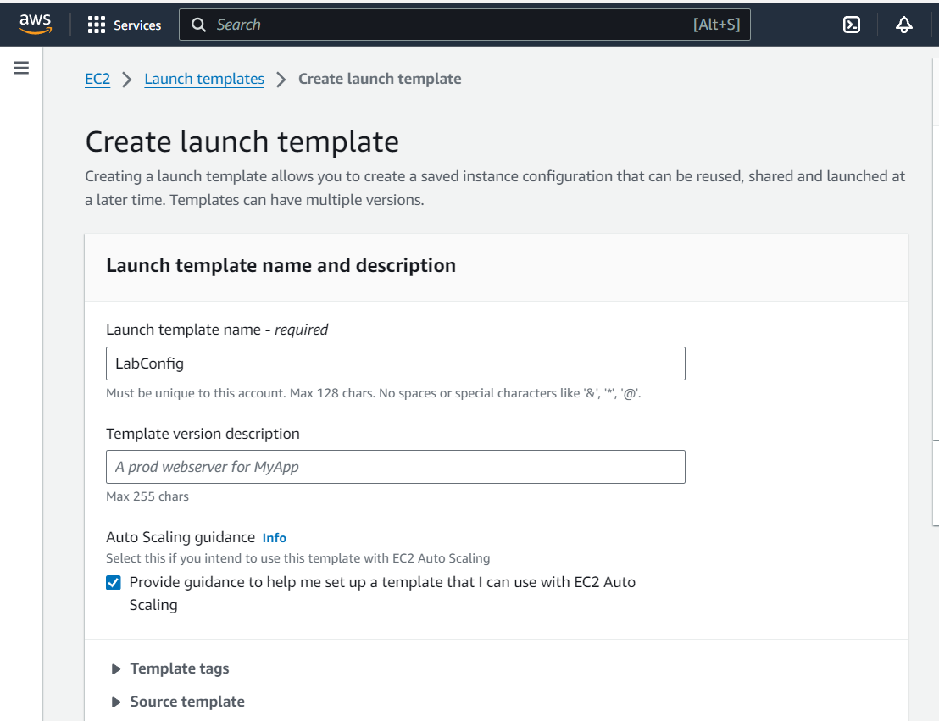

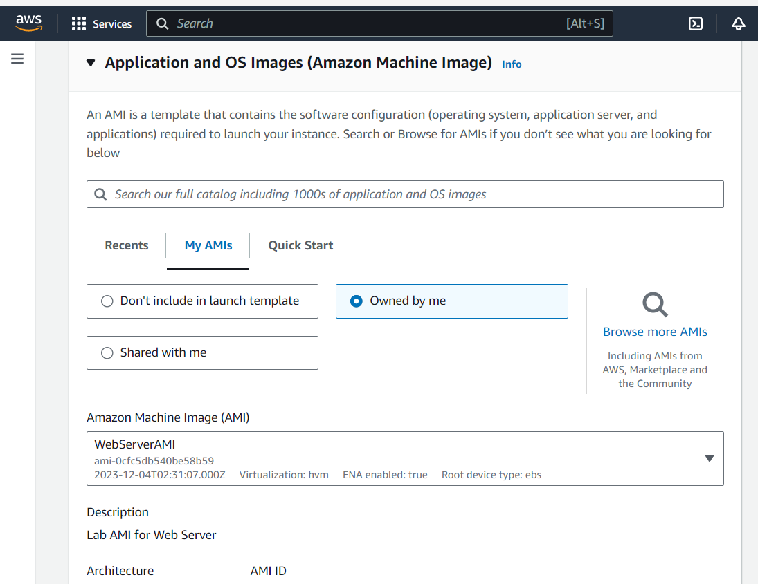

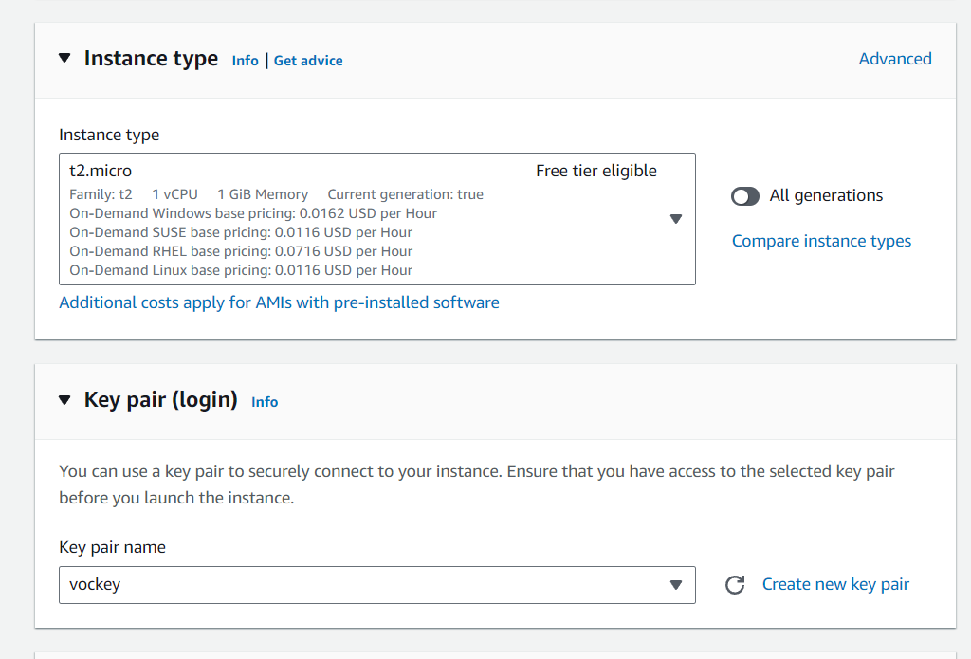

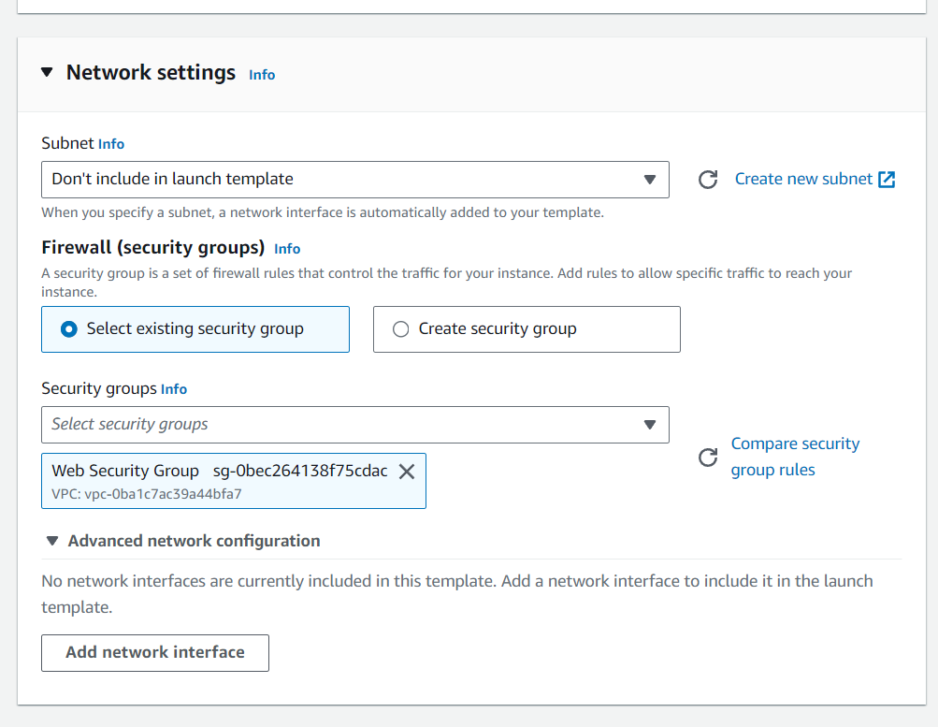

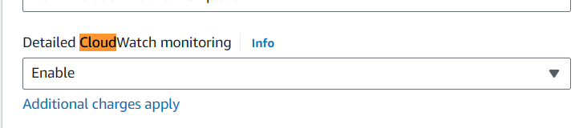

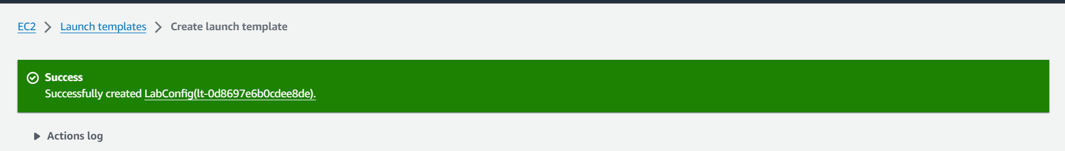

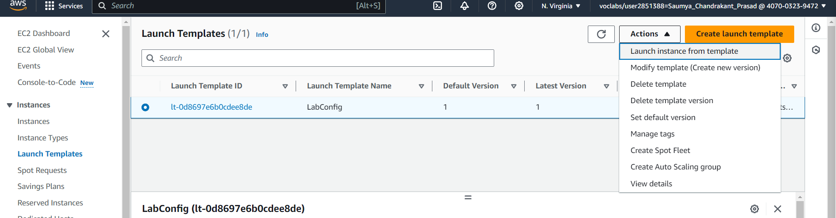

Creating auto-scale group

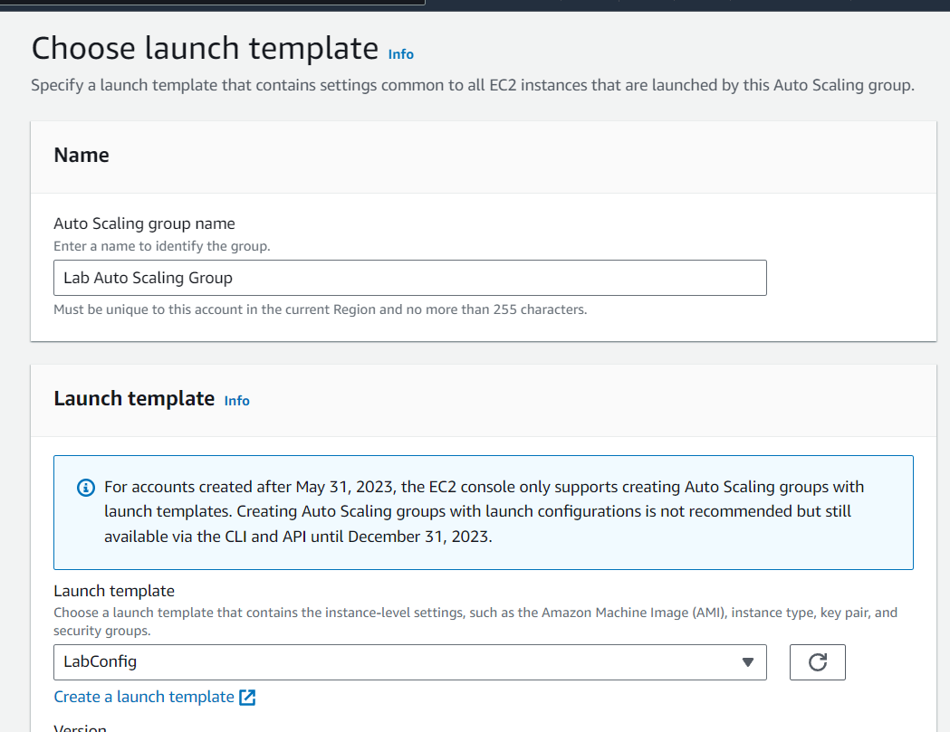

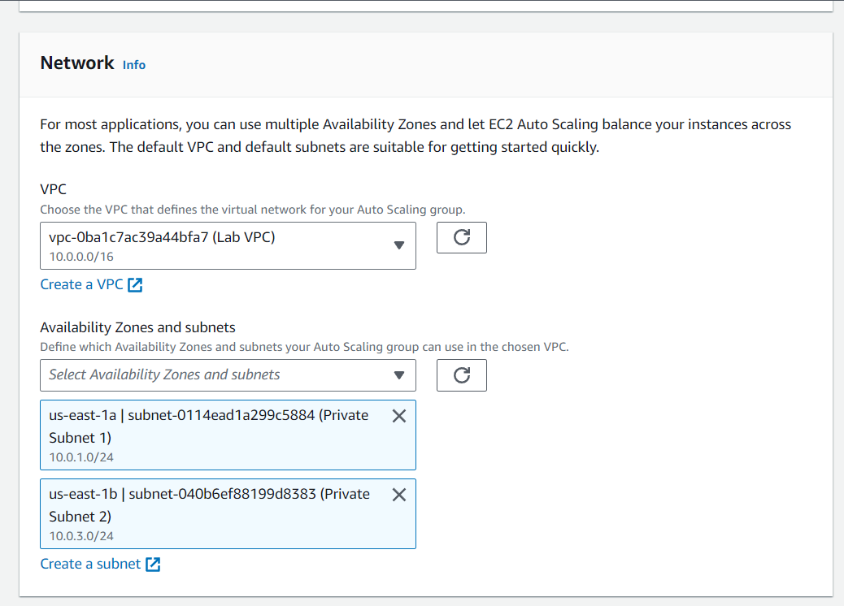

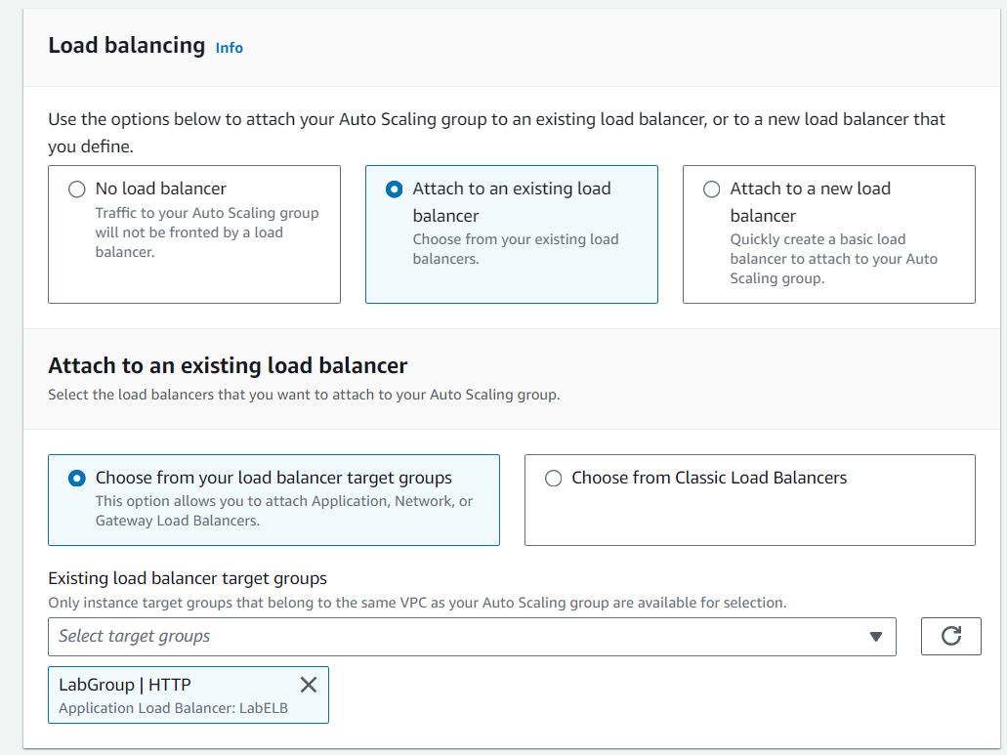

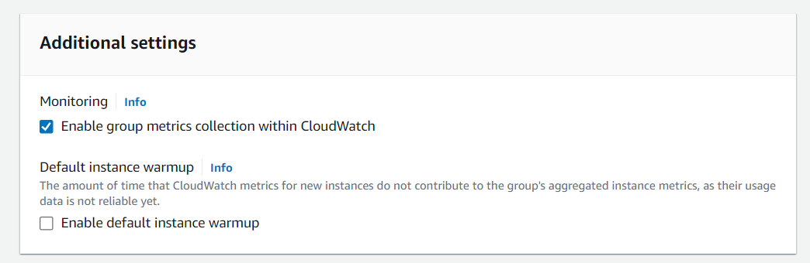

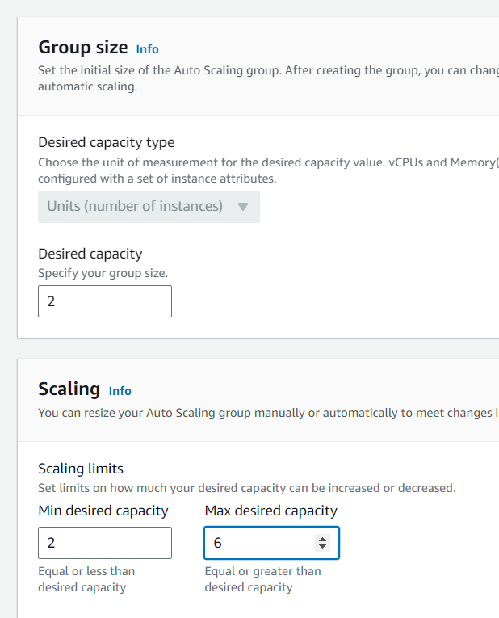

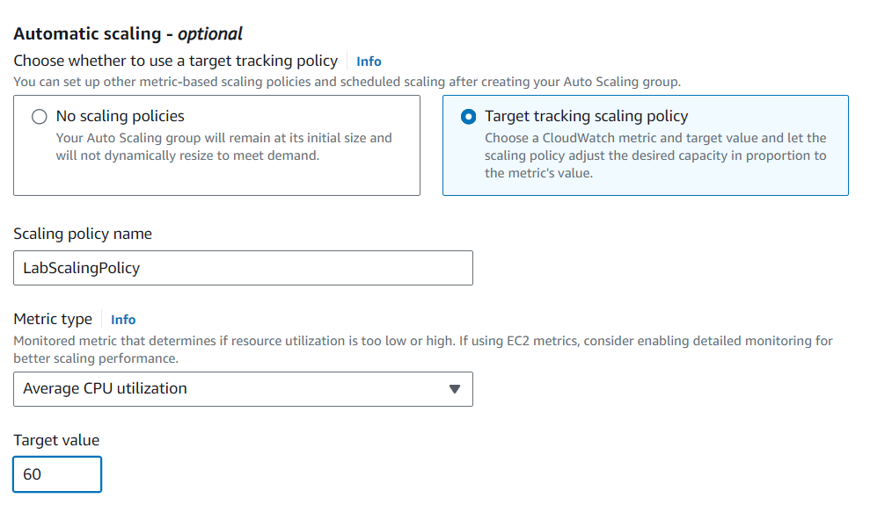

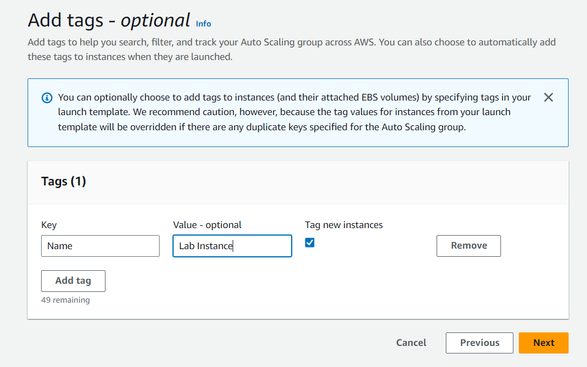

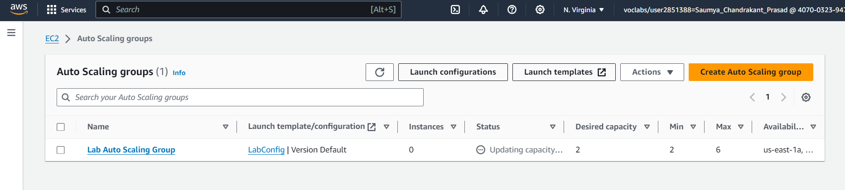

**Task 4 - Verify that Load Balancing is Working**

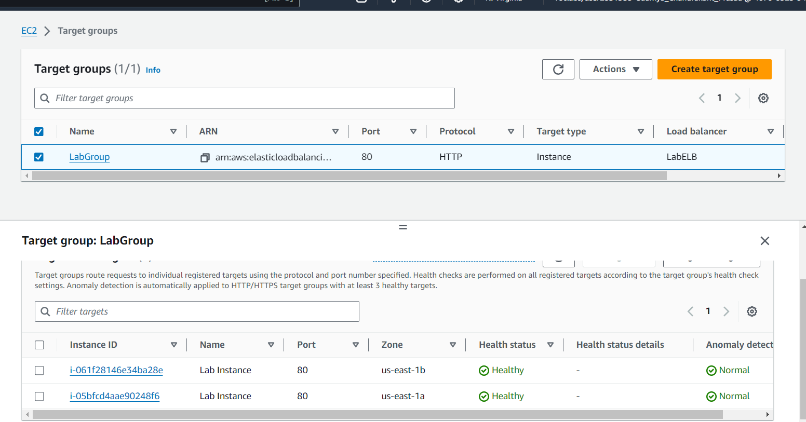

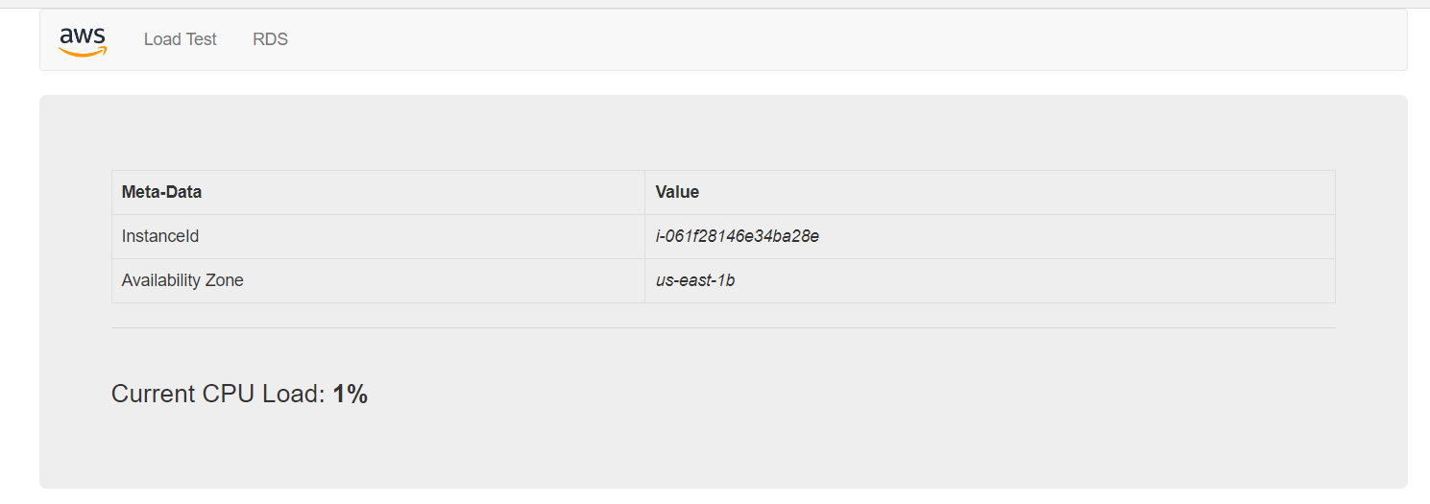

**Task 5 – Test Auto Scaling**

CloudWatch Alarms –

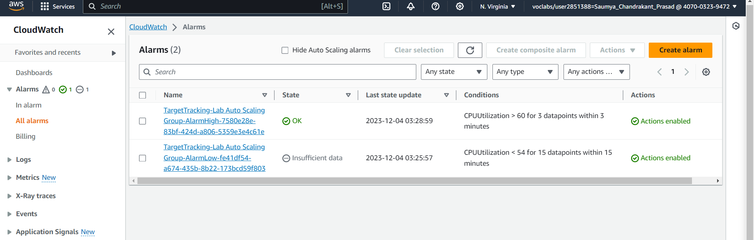

Updating the Auto-Scaling Group

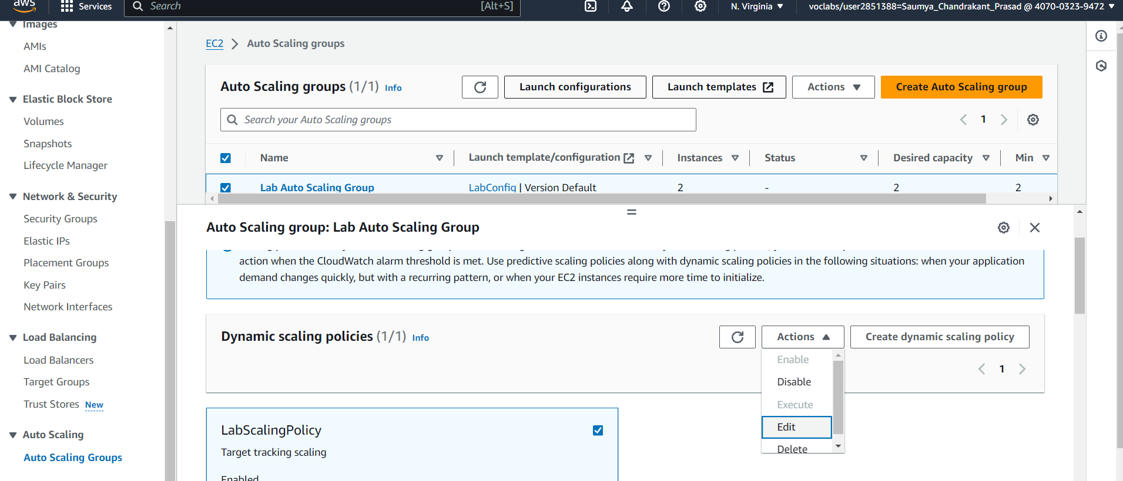

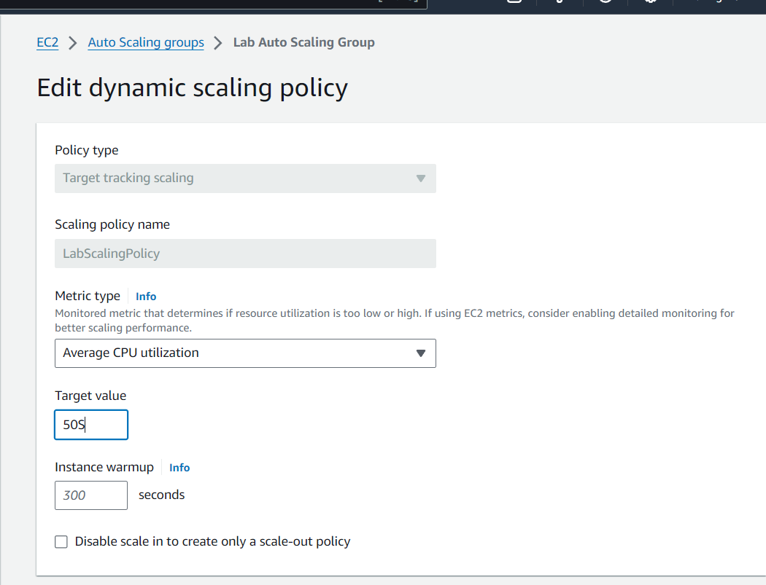

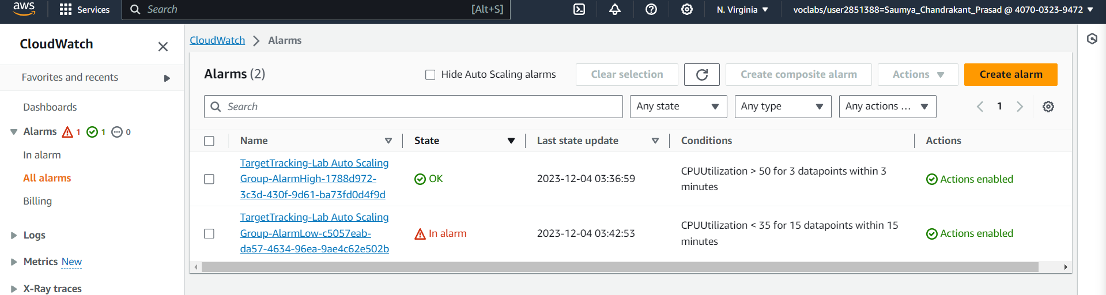

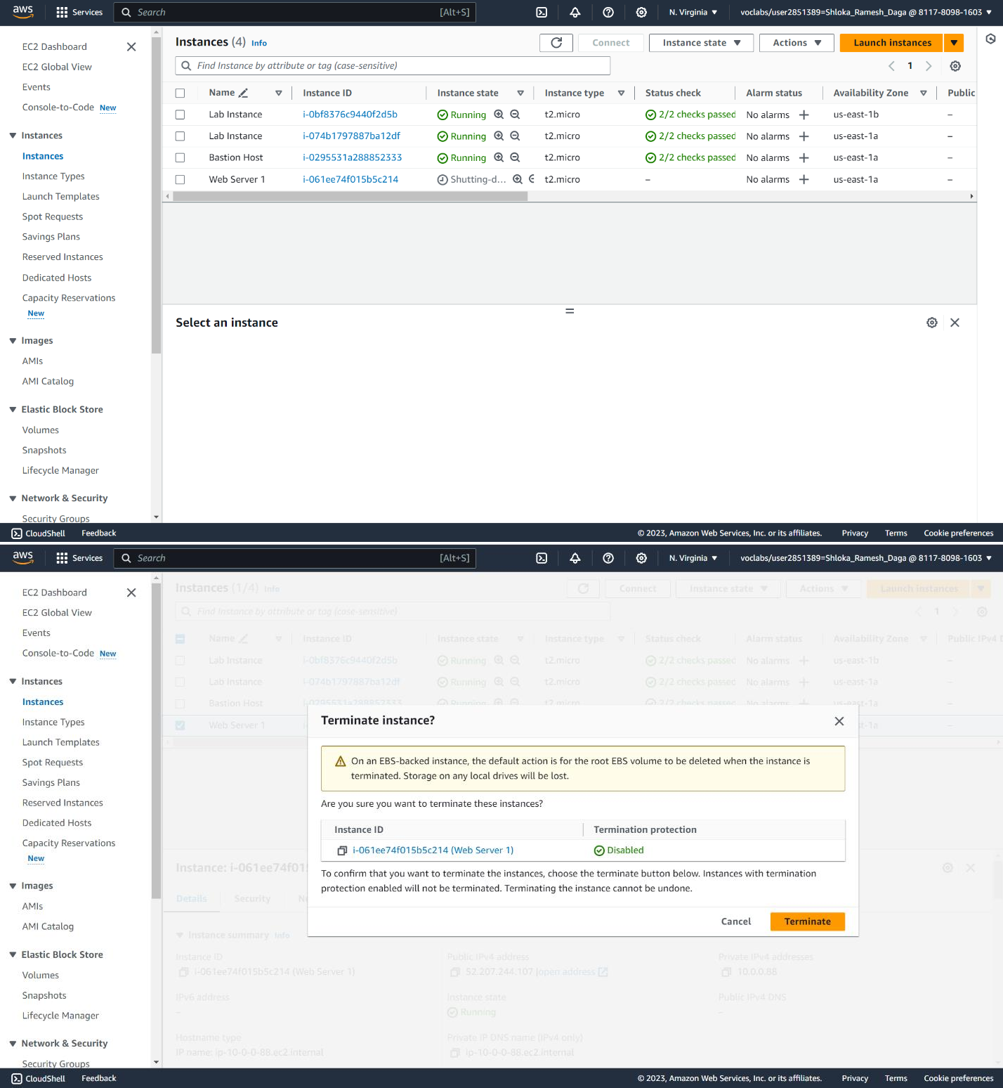

**Task 6 – Terminate Web Server 1**

